

**SOFTWARE REQUIREMENT SPECIFICATIONS**

**NUCES PORTAL**

SEHER SIDDIQUE K21-3568

ANAS KHAN K21-4761

Acknowledgement:

We would like to express our sincere gratitude to our course Teacher (Mam Shazia Paras) for her constant guidance and support throughout the course.

TABLE OF CONTENTS

**1.Introduction**

1.1 Purpose

1.2 Scope

1.3 Acronyms and Definitions

**2. Requirement Analysis**

**3. Detailed Description**

3.1 Dashboard

3.2 Past Papers

3.3 Study Resources

3.4 Collaboration With Seniors

**4. Additional Requirements**

**4.1 Functional Requirements**

4.1.1. Dashboard

4.1.2. Past Papers

4.1.3. Study Resources

4.1.4. Collaboration With Seniors

**4.2 Non-Functional Requirements**

4.2.1. User Interface

4.2.2. Security

4.2.3. Scalability

4.2.4. Availability

**5. Benefits**

**6. Use Case Diagram**

**7.Test cases**

**8.Gantt Chart**

**9. Conclusion**

1. Introduction

This document's goal is to give a thorough explanation of the specifications for creating a student portal website. Students will be able to examine old papers, find study aids, and interact with seniors thanks to the website. University students who require a venue for academic materials and peer communication are the intended audience for this website.

1.1 Purpose

This document's main goal is to give a detailed explanation of the specifications for a student portal that enables collaboration with seniors, access to past exams, and study resources.

1.2 Scope

Students can engage with seniors and view prior exams using the Student Portal, a web-based tool. It is intended to give students a central area to locate and access pertinent materials that will improve their learning process

1.3 Acronyms And Definitions

| Acronyms | DEFINITION |
| --- | --- |
| User | The Students , Staff , Teachers |
| Wordpress-WP | Millions of websites and blogs around the world are powered by the free and open-source content management system (CMS) known as WordPress. Using editable templates and themes, users can create and distribute digital material, including text, photos, and multimedia components. |
| SIS - Student Information System | A software programme that saves and manages student data, including personal data, is known as a student information system, or SIS. |
| SQL | To create, read, update, and delete data from a database, MySQL makes use of the Structured Query Language. While the majority of MySQL queries are executed automatically, users can also manually execute them to modify WordPress URLs and do other activities. |
| CMS - Course Management System | A software programme that makes it easier to create, organize, and distribute online material and educational resources is known as a course management system, or CMS. |

2. REQUIREMENT ANALYSIS

We also did a real time requirement gathering from the students of NUCES and this is what we got.

Forms response chart. Question title: How important is it for you to have access to past papers on the portal?
. Number of responses: 85 responses.

Forms response chart. Question title: 

What type of study resources do you find most helpful?

. Number of responses: 85 responses.

Forms response chart. Question title: How often would you like to have question answer sessions with seniors?
. Number of responses: 85 responses.

Forms response chart. Question title: What is your preferred method of contact for important Meetings with seniors?
. Number of responses: 85 responses.

Forms response chart. Question title: What other features or resources would you like to see in the student portal?

. Number of responses: 85 responses.

Forms response chart. Question title: Would you like to have the option to create and save your own study notes within the student portal?
. Number of responses: 85 responses.

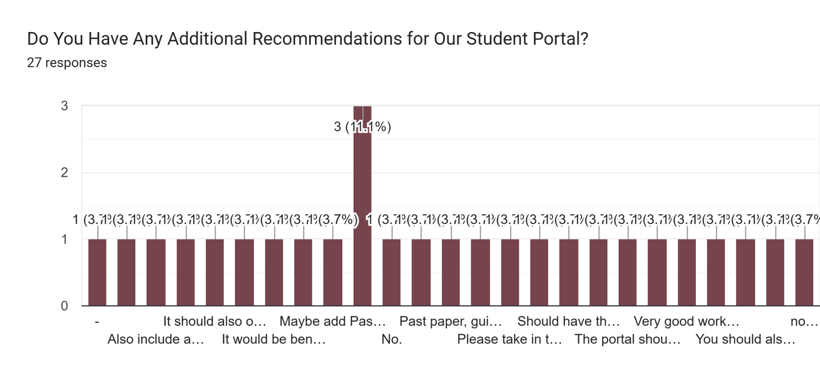

3. Detailed Description

Registered users of the student portal website will have access to past exams, study materials, and senior-level collaboration tools. To use the website's features, users must register for an account. The website will have a user-friendly layout that makes it simple for visitors to explore and get the information they need. The following attributes will be included on the website:

3.1 Dashboard

Users will be sent to their dashboard, which will show their profile details, the most recent changes, and a list of the courses they have signed up for

3.2 Past Papers

There will be a section on the website dedicated to prior papers from various semesters, years, and courses. The papers will be available for anyone to download and use for review.

3.3 Study Resources

The website will offer study tools for various courses, including lecture notes, presentations, and other items. The resources will be made accessible for anyone to download and use after being posted by seniors who have finished the courses.

3.4 Collaboration With Seniors

Users will be able to collaborate with seniors who have finished their course work using a feature on the website. Seniors will be available for users to consult with, offer advice to, and answer queries.

4. Additional Requirements

4.1 Functional Requirements

The following functional specifications have to be met by the website:

4.1.1. Dashboard

The user's profile information, most recent modifications, and a list of current courses should all be shown on the dashboard.

4.1.2. Past Papers

The website needs to feature a section for past papers from various semesters, years, and courses.

4.1.3. Research Tools

The website needs to include study materials for various courses, such as lecture notes, presentations, and other things. The resources should be able to be uploaded by instructors and accessed by students.

4.1.4. Collab with seniors

The website needs to contain a function that enables visitors to work with seniors who have finished their course work. Seniors need to be available for users to consult with and receive advice from.

4.2 Non-Functional Requirements

The following non-functional requirements should be met by the website:

4.2.1. User Interface

The website should have an intuitive layout that makes it simple for visitors to browse and get the information they need.

4.2.2. Security

The website needs to have a safe process that guards user information and shields it from unauthorized access.

4.2.3. Scalability

The website has to be expandable to handle plenty of visitors and resources.

4.2.4. Availability

Users should be able to access the website constantly, with little downtime required for updates and maintenance.

5. BENEFITS

Students using the student portal website will receive the following advantages:

· Academic Performance: Students can improve their academic performance and reach their educational objectives by using the past exams and study guides given on the website.

· Time management: By offering students practice materials like past exams and study guides, the website will assist students in developing their time management abilities.

· Insights from Seniors: Students will be able to learn from others who have already gone through similar situations thanks to the collaborations with seniors feature. They will be able to fulfill their academic objectives and better prepare for their exams as a result.

· Convenient Access: Students will save time and effort by having easy access to prior exams, study guides, and projects with seniors through the website.

6 . USE CASE DIAGRAM

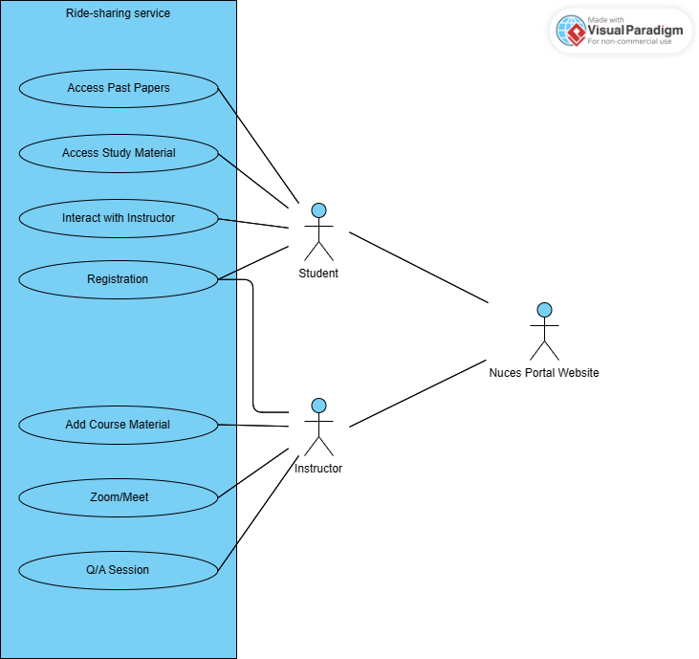

7. Test Cases

| Test Case Id | Objective | Pre-conditions | Expected  Result | Pass/Fail |
| --- | --- | --- | --- | --- |
| 01 | Verify that users can log in to the student portal. | Valid credentials. | The user should be redirected to the dashboard or homepage of the student portal. | Pass |
| 02 | Accessing Past Papers | Verify that students can access past papers for their enrolled courses. | The user should be able to view the selected past paper. | Pass |
| 03 | Accessing Study Material | Verify that students can access study material for their enrolled courses. | The user should be able to view the selected study material. | Pass |
| 04 | Interacting With Instructor | Verify that students can collaborate with Instructors for their enrolled courses. | The user and senior should be able to collaborate effectively | Pass |
| 05 | Logout | Verify that the student is logged out of the portal | The user should be logged out. | Pass |

8. Gantt Chart

Gantt Chart Fully Depends upon the Team size,Methodology, and dedication towards the project.The most important factor is the time and cost it takes.Here is the Documented Gantt chart for our Project :

| TASK | Start Date | End Date | Duration | Progress |
| --- | --- | --- | --- | --- |
| Design and Implementation | 10th May | 10th May | 2 days | Completed |
| Pre-Development Phase | 11th May | 12th May | 2 days | Completed |
| Development Testing Phase | 13th May | 13th May | 1 day | Completed |
| Release Testing  Phase | 14th May | 15th May | 2 days | Incompleted |

9. Conclusion

The specifications for creating a student portal website are fully described in this SRS document. Students will be able to examine old papers, find study aids, and interact with instructors thanks to the website. The website's user-friendly interface, secure login process, and scalability will all be present.